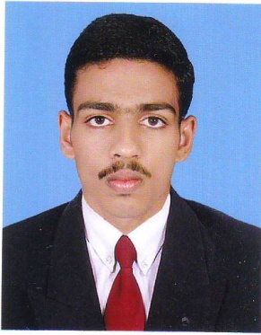
Curriculum Vitae

Sreekumar T.R
Reg .no. : 47297 (State Pharmacy Council, Kerala)
Passport No. : L 1600114, Valid up to 20/05/2023
Thalappulath House, Edavaramba (P.O.),Cherupuzha (via), Kannur -670511, Kerala, India.
Phone: +91 9809353843 (Mob.), +91 4985 213552 (Home)
Email : trsreekumar2@gmail.com

Intent
Seeking a reputable position as Hospital Pharmacist to apply my skills and knowledge in
the field of Medicines in a reputed organization.

Summary of Skills
- 36 Months of Hospital Pharmacist experience.
- Excellent customer service and inter personal skills.
- Capable to work independently and as a part of a dynamic team.
- Flexible, organized and team oriented.
- Good assessment and problem solving skills.
- Ability to bill and dispense pharmaceuticals according to the physician’s orders.
- Generates information on the use as well as effects and dosage of medications.
- Issues prescribed medicines in accordance with strict control procedures.
- Handle stocks and order supplies of medicines as well as maintain inventories of
pharmaceuticals.
- Positive attitude towards patients in critical situations.
- Preparations of purchase indent and purchase entry of medications

Professional work experience

November 2013 to present : Working as a Hospital Pharmacist in Lakeshore Hospital &Research center , Kochi, an NABH Accredited and ISO 9001:2000 certified,350 bedded tertiary level hospital.

January 2013 ‐ October 2013 : Worked as a Pharmacist in Friends Medicals, Pulingome, Kannur.

Education
Bachelor of Pharmacy from Rajiv Ghandi Institute of Pharmacy, Thrikaripur, during the period 2008-2013.

Academic Record
QUALIFICATION | NAME OF THE INSTITUTION | YEAR OF PASSING | & PERCENTAGE OF MARK
BACHELOR OF PHARMACY | RAJIV GHANDI INSTITUTE OF PHARMACY, THRIKARIPUR. | 2013 | (73.4%)
PLUS TWO | GOVT. HIGHER SECONDARY SCHOOL, KOZHICHAL | 2008 | (73%)
SSLC | ST.MARY’S HIGH SCHOOL ,  CHERUPUZHA | 2006 | (77%)

Personal Details

Date of Birth : 01/10/1990
Nationality : Indian
Sex : Male
Marital Status : Single

Academic Projects
- ANTHELMENTIC ACTIVITY OF VIDANGADI CHURNA (RESEARCH PROJECT)
- CADD: A POWERFUL TOOL IN DRUG DISCOVERY(REVIEW WORK)

Computer skills
Working knowledge on applications like MS Word, MS Power point, MS excel and proficient internet usage.

Hobbies
- Reading books
- Social networking
- Listening music
- Playing cricket & foot ball

References:

- Mr.Jacob P Mathews, Chief Pharmacist,Lakeshore Hospital & Research center Ltd.,Kochin Mobile : +91 9847862596
- DR:M PARIDHAVI,Principal,Rajiv Gandhi Institute of Pharmacy,Trikaripur
Email:paridhavin@yahoo.co.in,Ph.No:+919495675861
- Prof:Sajith,Dept of Pharmaceutical Chemistry,Rajiv Gandhi Institute of Pharmacy,Trikaripur,Ph.No: +919567033540

Declaration
I hereby declare that what I have furnished here is true and correct to the best of my knowledge.

Date : 05/11/2016 Sreekumar T.R
Place : Ernakulam

